Unified observability

Designing pipeline solutions
Welcome to this lesson on monitoring and troubleshooting orchestrated pipelines. You've learned now to orchestrate your complex batch workflows with Cloud Composer. But building and deploying is only half the battle.
Production systems are dynamic and
issues will arise.
For Cymbal Superstore, a "successful" DAG run isn't enough.
- What if it succeeded but took ten hours instead of one?
- What if it processed zero records?
This lesson is about achieving true operational excellence. You will focus on
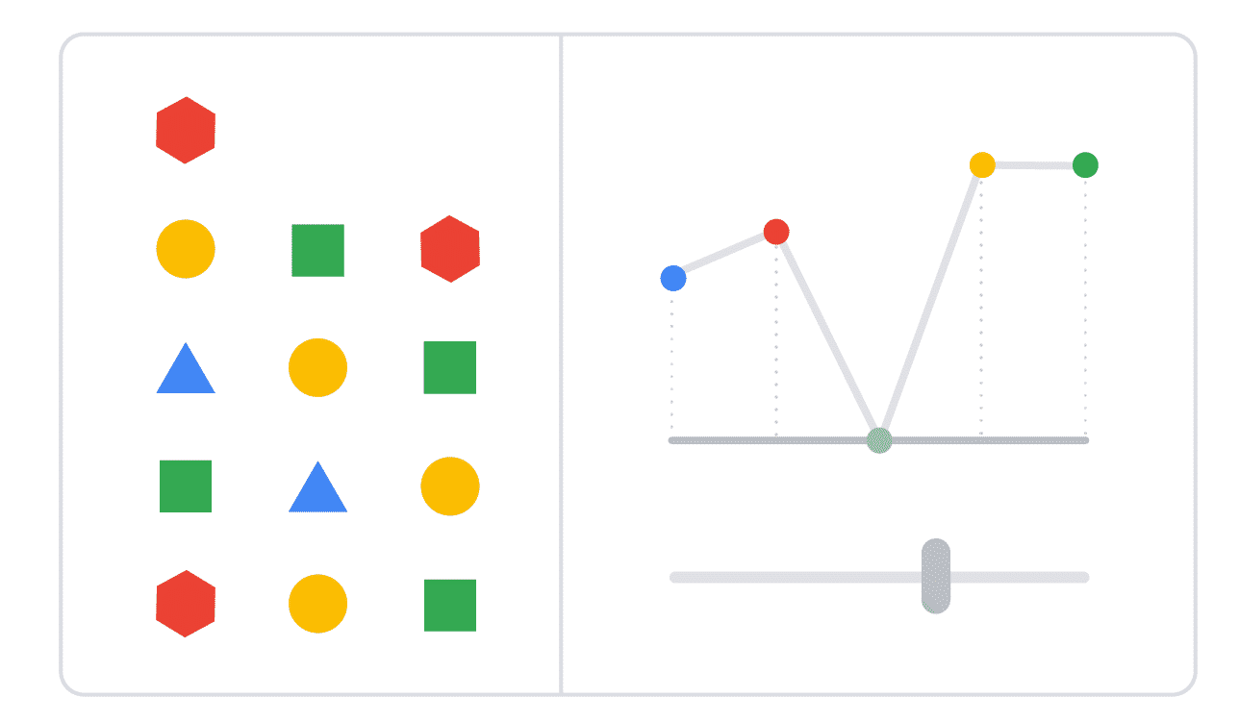
- Implementing unified observability, to create a single, clear view of your pipeline's health.
- Configuring proactive alerting, to warn you about issues before your users do.
- Employing systematic troubleshooting strategies to ensure the long-term health and reliability of your data pipelines.

Fragmented monitoring strategies
The daily financial report at Cymbal Superstore is late. The executive team wants to know why and your data engineering team needs to find the root cause immediately.
- Is the issue in the Composer DAG scheduler?
- Did the Dataflow ingestion job hang?
- Did the Serverless for Apache Spark aggregation job fail?
To figure out why, you have to dig through separate logs for Composer, Dataflow, and Spark. Hunting for clues in different places while the clock is ticking is stressful and slow.
In a complex, orchestrated system, looking at each component's logs and metrics in isolation is slow and inefficient. It is difficult to understand the overall workflow when focused on individual components. This is why a fragmented monitoring strategy is a liability.

Unified observability
The modern solution is unified observability - having a single place or view, where you can correlate signals from across your entire system. It’s not just about collecting logs and metrics; it’s about seeing how a performance spike in one service relates to an error message in another.
On Google Cloud, this is achieved through the tight integration of Cloud Monitoring
(opens in a new tab)
and Cloud Logging
(opens in a new tab)
. All Google Cloud services, including Composer, Dataflow, and Serverless for Apache Spark, automatically send their metrics and logs to these central services.
This allows you to build a holistic view of your entire orchestrated workflow—from the Composer task status down to the performance of an individual Dataflow worker—all in one place. This ability to correlate a metric spike in a Monitoring dashboard directly to the relevant error logs in Logging is what transforms troubleshooting from a reactive chore into a proactive science.

Proactive monitoring
Effective monitoring allows you to detect performance regressions, spot data quality issues, and debug failures quickly. To assess pipeline health, you will track key metrics that provide a holistic view of performance and reliability. These include:
Click each button to expand the 3 items and learn more.

Workflow Health
- DAG run duration
- Task success/failure rate
- Task retry count

Data Health
- Data freshness/lag (how late is the data?)
- Processed record count
- Dead letter queue (DLQ) count

Performance and Cost
- Resource utilization (Dataflow vCPU, Spark executor memory)
- BigQuery slot usage
Instead of just looking at these metrics individually, the best practice is to assemble them into a dedicated custom dashboard in Cloud Monitoring. For more details, check out the official documentation
(opens in a new tab)
on creating custom dashboards in Cloud Monitoring

Transcript

Structured logs
Your dashboards are excellent for spotting trends, but when a pipeline job fails at 3 AM or performance slowly degrades over a week, you need to find the specific error log entry—the "needle in the haystack."
Manually searching through potentially terabytes of log files from thousands of distributed workers is impossible. Furthermore, you shouldn't have to stare at a dashboard all day. Your system should actively inform you when something goes wrong, from infrastructure failures to subtle data quality issues.
This is where you move from passive monitoring to active, actionable insights.

Concepts for deep observability
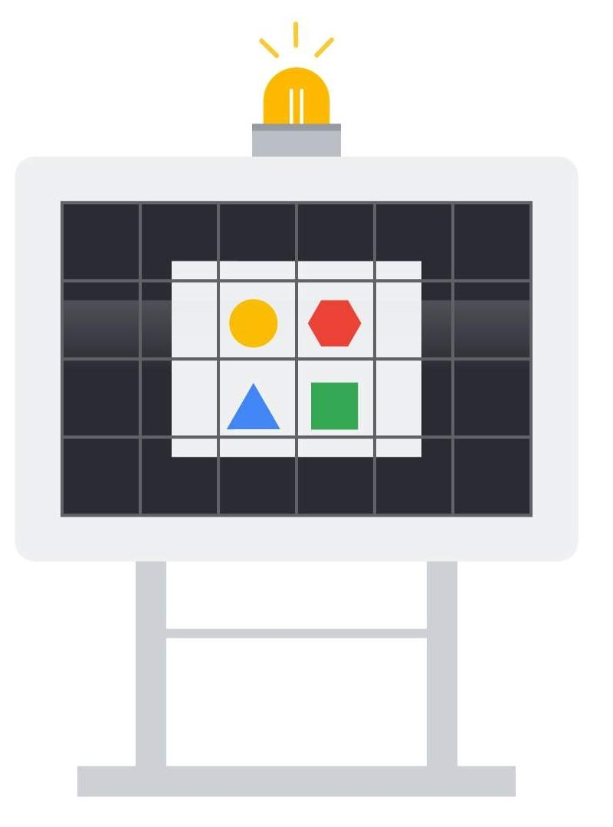
On Google Cloud, you can achieve deep observability by leveraging two core capabilities of the Cloud Logging suite:
- Centralized log analysis: Cloud Logging is a fully managed service that automatically ingests, stores, and analyzes log data from every component in your pipeline—Composer, Dataflow, and Serverless for Apache Spark. By writing structured logs (machine-readable JSON), you transform your logs from simple text into a powerful, queryable database to pinpoint the root cause of any issue.
- Proactive alerting: You can create policies that automatically notify you when specific conditions are met. This includes not only system-level metrics (like a job failure) but also alerts based on the content of the logs themselves (a log-based alert), such as a sudden spike in data validation errors.

Batch pipeline logging
Step 1: Structured Logs
Step 2: Log Explorer
Step 3: Analysis with SQL
The foundation of all advanced analysis is emitting high-quality, structured logs from your Dataflow or Spark code.
By logging a JSON payload, you are adding critical, queryable context to your log entries, such as the specific business transaction that failed and the unique ID of the orchestrated workflow it belonged to.
The following is an example of Python code used in a DAG for structured logging in for Dataflow or Apache Spark workloads.

Code for structured logs
# This function could be part of a Dataflow DoFn or a Spark map function.
def process_transaction(element):
# In a real application, the client is often initialized once per worker.
from google.cloud import logging as gcp_logging
log_client = gcp_logging.Client()
logger = log_client.logger("financial_pipeline_logs")
# The correlation_id would be passed in as a pipeline argument from
# the Cloud Composer DAG, e.g., using context variables like dag_run.run_id
correlation_id = "scheduled__2025-08-29T14:00:00+00:00"
try:
# Business logic to validate the transaction
amount = element.get("amount")
# CORRECTED: Check for None first to avoid a TypeError
if amount is None or not isinstance(amount, (int, float)) or amount < 0:
raise ValueError("Invalid or missing transaction amount.") # Using ValueError is more specific here
#... more validation...
except Exception as e:
# Log a structured payload for actionable, queryable insights
error_payload = {
"message": f"Transaction validation failed: {str(e)}",
"severity": "ERROR",
"transaction_id": element.get("transaction_id"),
"pipeline_stage": "validation",
"correlation_id": correlation_id
}
logger.log_struct(error_payload)
# Optionally, you would then yield this element to a Dead Letter Queue.
return # Stop processing this record
#... continue processing valid record...
Watch the following video which covers structured logging and other Cloud Logging best practices.

Additional resources
Google Cloud's Well-Architected Framework: Operational excellence. Click Observability to learn more.
Observability
Cloud Logging's log buckets are a feature that allows you to store and organize your log entries for analysis and retention. Click Log Buckets to learn more.
Log Buckets

